String Grid Smoothing Macro
  - User Reference Guide
A practical user guide for configuring, running, and reviewing the String Grid Smoothing macro in 12d Model V15.
Document type  User reference guide | Application  12d Model V15 | Macro  String Grid Smoothing

1. Purpose
The String Grid Smoothing macro is a 12d Model V15 macro for smoothing elevation values in an existing String_Grid element.
It is intended for cleaning or softening gridded terrain elevation data, especially where the grid contains localised elevation noise, small spikes, or rough contour behaviour. The macro creates a new output String_Grid and does not intentionally modify the original input grid.
The macro is not a TIN-to-grid converter, point-cloud classifier, survey validation tool, or replacement for engineering review. The output should always be checked before being used for design, volumes, drainage, construction, or modelling decisions.

2. Important Warnings
Warning: Use this macro at your own risk.
Before pressing Process, complete the following checks:
- Save the 12d project.
- Confirm the input grid and output model are correct.
- Use conservative settings first.
- Test on a small area or copied grid where possible.
The macro may take several minutes on large grids. While processing, 12d Model may appear busy or unresponsive. The macro does not provide live progress updates. Wait until the macro finishes and prints its report to the Output Window.
If 12d Model is force-closed while the macro is running, unsaved work may be lost.

3. What the Macro Does
The macro:
- Reads the selected input String_Grid.
- Reads the grid geometry, dimensions, spacing, and elevations.
- Creates a new output String_Grid.
- Applies one or both optional smoothing stages:
  - Median Spike Filter
  - Gaussian Smoothing
- Writes the smoothed elevations to the output grid.
- Prints a processing report to the 12d Output Window.
The original input grid is retained for comparison.

4. Panel Overview

Figure 1. String Grid Smoothing panel
This figure shows the main macro panel and the key controls used to configure and run the smoothing process.
Panel controls and descriptions
Use the panel to define the source grid, select the output destination, and control how strongly the smoothing routines are applied.
Control | Description
Input String_grid | Select the existing String_Grid to smooth.
Output String_grid name | Enter the name of the new smoothed grid.
Output model | Select or create the model where the output grid will be placed.
Use median spike filter | Enable or disable the median filter stage.
Median window size | Use an odd number, usually 3. Larger values are slower and more aggressive.
Spike tolerance | Set the maximum allowed difference from the neighbourhood median before replacement occurs.
Minimum valid neighbours | Set the minimum valid surrounding cells required before the median filter is applied.
Use Gaussian smoothing | Enable or disable Gaussian smoothing.
Gaussian radius | Set the search radius around each cell.
Gaussian sigma | Control smoothing strength.
Gaussian passes | Set the number of Gaussian smoothing passes.
Maximum vertical change | Limit the maximum allowed vertical change per Gaussian pass.
Process | Start the smoothing process.
Finish | Close the panel.
Help | Open macro help, if configured.

5. Median Spike Filter
The median spike filter is intended to reduce isolated high or low cells.
For each grid cell, the macro:
- Looks at neighbouring cells inside a square window.
- Ignores invalid or undefined cells.
- Excludes the centre cell from the neighbour list.
- Calculates the median elevation of valid neighbours.
- Compares the current cell elevation against that median.
- Replaces the cell only if the difference exceeds the spike tolerance.
Decision rule
\(|z_{cell}-z_{median}|\)
If \(|z_{cell}-z_{median}|>T_{spike}\), then \(z_{out}=z_{median}\)
Otherwise, \(z_{out}=z_{cell}\)
Where: z_{cell} is the current cell elevation, z_{median} is the neighbour median elevation, and T_{spike} is the spike tolerance.
The median filter is useful for isolated spikes, but it can alter real terrain breaks if the tolerance is too low.
Use caution near:
- retaining walls
- steep banks
- kerbs
- cliffs
- drains
- bridge edges
- hydro-flattened water edges
- sharp batters
A steep real feature can look like a spike because neighbouring cells may be much higher or lower.

6. Gaussian Smoothing
Gaussian smoothing applies a weighted average using nearby cells. Closer cells have more influence than distant cells.
For each neighbouring cell within the Gaussian radius:
\(w=\exp\left(-\dfrac{d^2}{2\sigma^2}\right)\)
Where:
- w = Gaussian weight
- d = horizontal distance from the current cell
- σ = Gaussian sigma
The smoothed value is:
\(z_{weighted}=\dfrac{\sum_i w_i z_i}{\sum_i w_i}\)
The macro then limits the vertical change using Maximum vertical change:
\(\Delta z=z_{weighted}-z_{current}\)
Clamp \(\Delta z\) to the range \([-\Delta z_{max},\,+\Delta z_{max}]\)
Gaussian smoothing is useful for softening noisy surfaces, but large radius, high sigma, or multiple passes can over-smooth terrain.

7. Recommended Starting Parameters

Conservative Default
Use this as the recommended starting point for most grids.
Setting | Value
Use median spike filter | ON
Median window size | 3
Spike tolerance | 0.100
Minimum valid neighbours | 3
Use Gaussian smoothing | ON
Gaussian radius | 3.000
Gaussian sigma | 1.000
Gaussian passes | 1
Maximum vertical change | 0.500

Median-Only Diagnostic
Use this set to check whether isolated spikes are being removed without adding broader surface smoothing.
Setting | Value
Use median spike filter | ON
Median window size | 3
Spike tolerance | 0.100 to 0.300
Minimum valid neighbours | 3 to 5
Use Gaussian smoothing | OFF

Gaussian-Only Light Smoothing
Use this where the surface is generally correct but visually noisy and only light smoothing is required.
Setting | Value
Use median spike filter | OFF
Use Gaussian smoothing | ON
Gaussian radius | 2.000 to 3.000
Gaussian sigma | 1.000
Gaussian passes | 1
Maximum vertical change | 0.100 to 0.500

Aggressive Diagnostic Only
Diagnostic use only
Use these settings for testing rather than production output.
Setting | Value
Median window size | 5 or 7
Spike tolerance | 0.010 to 0.050
Minimum valid neighbours | 8 or more
Spike tolerance: 0.010 to 0.050
Minimum valid neighbours: 8 or more
This can greatly increase runtime and may remove real terrain detail.

8. Runtime Guidance
Runtime depends mainly on:
- number of grid cells
- median window size
- Gaussian radius
- Gaussian passes
General rules of thumb
- Larger grids take longer to process.
- Larger median windows are significantly slower.
- Larger Gaussian radii increase runtime.
- More Gaussian passes increase runtime approximately linearly.
For large grids, avoid starting with aggressive settings. A 5x5 median window can take several times longer than a 3x3 window because many more neighbour values must be checked and sorted.

9. Output Report
When processing finishes, the macro prints a report to the 12d Output Window.
Typical report items include:
- Input grid
- Output grid
- Output model
- Input data size
- Grid dimensions
- Grid spacing
- Loaded input grid height cells
- Written output grid height cells
- Skipped or undefined cells
- Median altered cells
- Gaussian altered cells
- Maximum lowering
- Maximum raising
- Mean vertical change
- Standard deviation of change
- Processing time
Difference Meaning
The vertical difference is:
\(\Delta z=z_{output}-z_{input}\)
So:
- Negative difference means the output is lower than the input.
- Positive difference means the output is higher than the input.
- Maximum lowering is the largest downward change.
- Maximum raising is the largest upward change.
- Mean vertical change shows overall bias.
- Standard deviation shows spread of changes.
Large maximum raising/lowering values should be reviewed. They may indicate real spikes, but they may also occur near genuine sharp terrain breaks.

10. Suggested Workflow
- Save the project.
- Select the input String_Grid.
- Enter a new output grid name.
- Select or create an output model.
- Start with conservative settings.
- Press Process.
- Wait for the macro to finish.
- Review the Output Window report.
- Display the original and smoothed grids separately.
- Compare contours or TINs generated from both grids.
- Adjust parameters gradually if needed.
- Keep the original grid for reference.

Figures
Figure 1. Macro Panel Overview

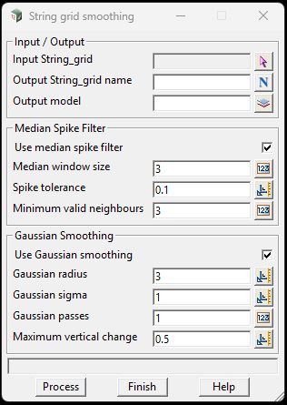
1 Input String_grid
Figure 1: String Grid Smoothing panel showing input/output controls, Median Spike Filter parameters, Gaussian Smoothing parameters, and processing buttons.
2 Output String_grid name
3 Output model
4 Use median spike filter
5 Median window size
6 Spike tolerance
7 Minimum valid neighbours
8 Use Gaussian smoothing
9 Gaussian radius
10 Gaussian sigma
11 Gaussian passes
12 Maximum vertical change

Figure 2 — Original Grid Contours
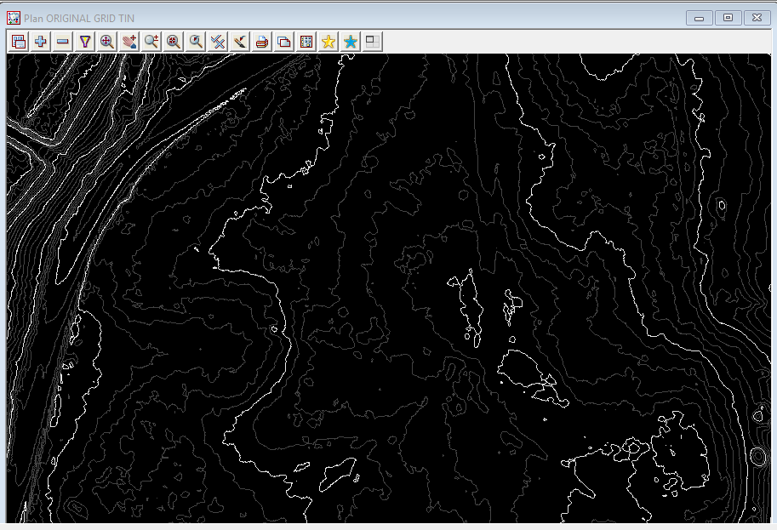
Figure 2: TIN contours generated from the original/pre-processing String_Grid. The contours show local irregularity and roughness before smoothing.
Suggested annotations
- “Original/pre-processing grid”
- “Sharper local variation”
- “No smoothing applied”

Figure 3 — Smoothed Grid Contours
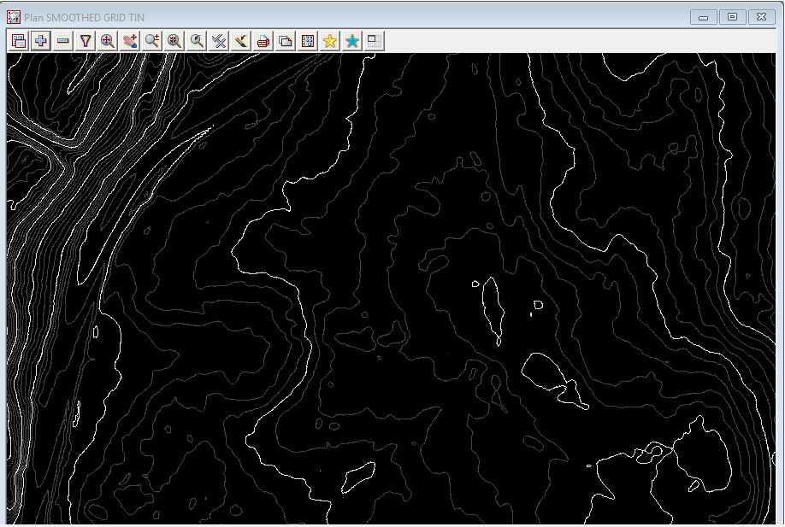
Figure 3: TIN contours generated from the smoothed String_Grid. The contours are visually smoother after applying the selected median/Gaussian settings.
Suggested annotations
- “Smoothed grid”
- “Reduced local roughness”
- “Check sharp terrain features before relying on output”

Figure 4 — Side-by-Side Comparison
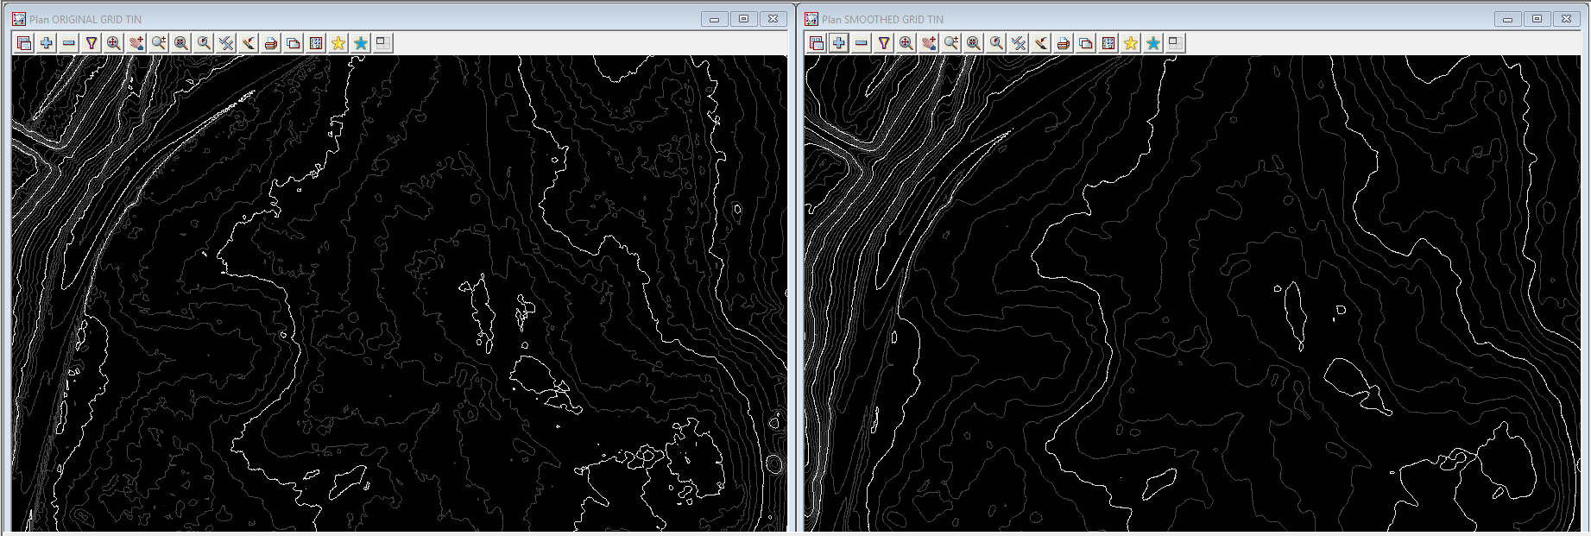
Figure 4: Comparison of TIN contours from the original String_Grid and the smoothed String_Grid. The smoothed result may improve contour presentation, but users must verify that real terrain breaks have not been over-smoothed.
Suggested callouts
Left: Original grid-derived TIN contours
Right: Smoothed grid-derived TIN contours
Smoother contour flow after filtering
Review steep banks, retaining walls, drains and edges

